**GitHub Copilot – Getting started (Visual Studio)**

**Prerequisites:**

* Compatible version of Visual Studio (2022 17.8 or later)
* Create a GitHub account with your Syntegon email address.
* Click on the GitHub Copilot button in the top right corner of Visual Studio and select *“Add GitHub account to Visual Studio...”.* Follow the instructions to sign in to your account.

Ein Bild, das Text, Screenshot, Schrift enthält.

* Copilot is active and fully functional if you signed into Visual Studio with a GitHub account that has an active subscription to GitHub Copilot. Using the dropdown menu, you can easily open the Chat window, access Copilot settings, and manage Copilot subscription.

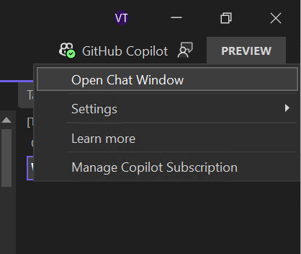

**Chat with GitHub Copilot:**

1. Open an existing code file.
2. In the Visual Studio menu bar, click *View*, then click *GitHub Copilot Chat*.

Ein Bild, das Text, Screenshot, Schrift, Zahl enthält.

1. In the Copilot Chat window, type “*what does this file do”* and then press *Enter*. Copilot's answer is displayed below your question. You can specify the file you want to reference by *“#<filename>”.*

Ein Bild, das Text, Screenshot, Schrift enthält.

1. Select a line of code in the editor.
2. In the Copilot Chat window, type “*explain this line”* then press *Enter*.

Ein Bild, das Text, Screenshot, Schrift, Software enthält.

**Code completion:**

1. Open Visual Studio.
2. Create a new JavaScript(*.js) file.
3. In the JavaScript file, type the following function header:

*function calculateDaysBetweenDates(begin, end) {*

GitHub Copilot will automatically suggest an entire function body in grayed text. The exact suggestion may vary.

Ein Bild, das Text, Screenshot, Schrift enthält.

1. To accept the suggestion, press *Tab*.

**Useful links:**

* [**Quickstart for GitHub Copilot: https://docs.github.com/en/copilot/quickstart?tool=visualstudio**](https://docs.github.com/en/copilot/quickstart?tool=visualstudio)
* [**Getting code suggestions in your IDE with GitHub Copilot: https://docs.github.com/en/copilot/using-github-copilot/getting-code-suggestions-in-your-ide-with-github-copilot**](https://docs.github.com/en/copilot/using-github-copilot/getting-code-suggestions-in-your-ide-with-github-copilot)
* [**Asking GitHub Copilot questions in your IDE: https://docs.github.com/en/copilot/using-github-copilot/asking-github-copilot-questions-in-your-ide**](https://docs.github.com/en/copilot/using-github-copilot/asking-github-copilot-questions-in-your-ide)
* [**Prompt engineering for GitHub Copilot: https://docs.github.com/en/copilot/using-github-copilot/prompt-engineering-for-github-copilot**](https://docs.github.com/en/copilot/using-github-copilot/prompt-engineering-for-github-copilot)